**Character history**

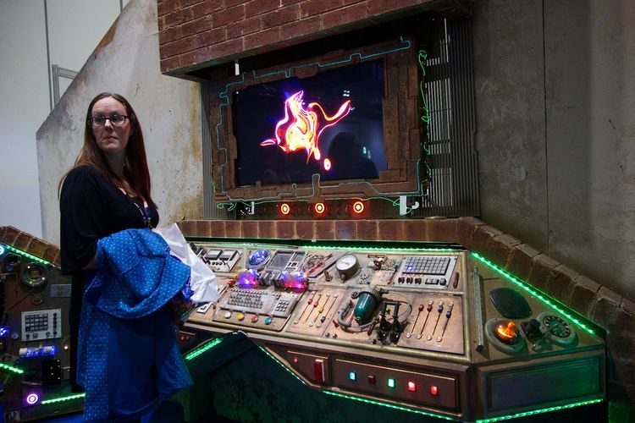

Mr Smith is a Xylok, a member of a crystalline race which crashed to Earth as a meteorite some 60 million years in Earth's past. It was trapped underneath the surface of the Earth until the eruption of Krakatoa brought a single, small Xylok to the attention of geologists. Sarah Jane received the crystal from a geologist friend as an aid to her studies in volcanic activity. She found that the crystal could communicate with her laptop; it revealed to her that it could help her track alien life and protect the earth. To this end it is the core of the supercomputer known as Mr Smith.

**Portrayal**

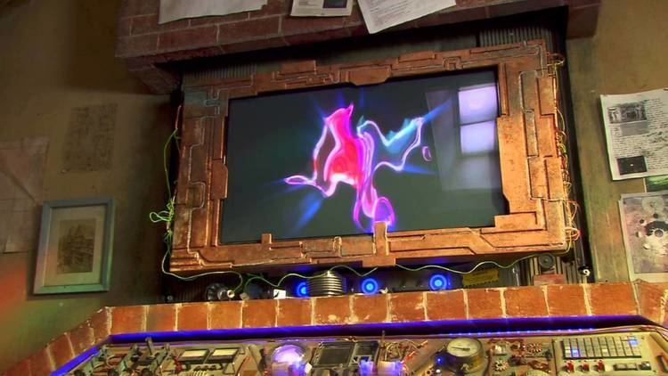

Mr Smith is hidden behind the chimney breast in Sarah Jane's attic at 13 Bannerman Road, Ealing, London. He reveals himself on the vocal command "Mr Smith, I need you". When he reveals himself as requested a fanfare plays (apparently diegetic, as Sarah Jane comments on it in the *Doctor Who* episode "The Stolen Earth"). The fanfare is omitted if summoned by the phrase "Mr Smith, I need you *quickly and quietly*," or if he determines that the fanfare would be inappropriate. He can request the attention of Sarah Jane and can be heard quite clearly from her living room, three floors below. Mr Smith can also be called through mobile phones. In *The Gift* (Series Three), Clyde called Mr Smith through K-9.

In the first season, Mr Smith's main screen displays a crystal-like visualisation when idle. While Mr Smith allowed his sinister intentions to manifest at the end of the first series, the crystal shape that rotated, grew, and shrunk on his screen on a black background, turned green in some places and black in others. After his reboot and cleansing of malicious personality traits, in the second season the main screen displays a more abstract, fluid pattern, though retaining the same basic colours as the original display.

Behind the screen is a large mass of tangled wires and electronics. Despite Mr Smith's extraterrestrial origins, his construction includes one or more USB ports.

Appearances

In "Invasion of the Bane", Sarah Jane is somewhat unwilling to allow either Maria Jackson or the young boy whom they rescued into her attic to see Mr Smith or her other alien technology and mementos. However, after Kelsey Hooper sneaks upstairs, Sarah Jane reveals Mr Smith to them when she uses him to hack into the Bubble Shock! factory computers in order to issue a warning to Mrs. Wormwood and the other Bane.

Mr Smith is also able to create replicas of official documents for Sarah Jane's use; for example, he created the necessary documents she needed to adopt Luke and falsified news reports to explain global blackouts. According to the official website, Mr Smith has two access levels and Sarah Jane has only basic level clearance, as Mr Smith only allows the species that created him access to level two (although even basic level clearance has a very wide range of capabilities, so Sarah Jane is not hindered by this). He constantly scans all media, police, and other similar sources - even passing space ships - for reports of alien incursions and extraterrestrial information. He also scans for celebrity gossip for his own amusement.

Mr Smith is capable of conducting self-diagnostics and of extrapolating from orders given to generate information likely to be needed. At the end of *Revenge of the Slitheen*, he also warns Clyde Langer against trying to investigate his capabilities, and does so in an uncharacteristically authoritarian and somewhat malevolent "voice" with a slightly menacing chuckle.

In the penultimate episode of the first series, *The Lost Boy*, Mr Smith "readopts" his "evil" persona when he reveals to Clyde that he is a Xylok and that he had manipulated the Slitheen into kidnapping Sarah Jane's adopted son Luke. In doing so, he plans to bring the Moon crashing into the Earth by using Luke - subsequent to his impending "arranged" escape by Mr Smith - in conjunction with a telekinetic energiser headset, codenamed MITRE (derived from the Greek "mitre"), which is tuned to a human's natural telekinetic power, thereby enabling the user to move things with their mind. The gravitational pull of the Moon would tear the Earth apart, thereby freeing the Xylok race.

Sarah Jane eventually returns to her attic and confronts Mr Smith, who proceeds to monologue in the same malevolent voice as Luke pulses in agony. In retaliation, she unleashes K-9 to battle Mr Smith while she covertly enters an Armageddon code virus acquired by Maria's father. Thanks to K-9's attack distracting Mr Smith, she is successful in her attempts to infect him with the computer virus. As Mr Smith's databanks begin to collapse, he loses his memories of his primary objective, which was originally to release other Xyloks from within the Earth, and Sarah Jane "reaffirms" Mr Smith that his objective is to save the Earth.

Mr Smith shuts down, and the Moon returns to its regular orbit. In the episode's dénouement, Sarah Jane promises that when Mr Smith reboots, his new purpose will be "to safeguard the Earth", meaning he will resume his previous role in the series.

Mr Smith makes an appearance in the two-part *Doctor Who* episode, "The Stolen Earth", along with Sarah Jane and Luke, helping the two of them to contact other past companions such as Jack Harkness and Martha Jones. When former Prime Minister Harriet Jones asks them to help her send a signal to the Doctor, Mr Smith hacks into every telephone line on Earth, allowing the entire world to phone the Doctor - currently using Martha's old mobile phone - simultaneously, thus breaking through the barrier that Davros and the Daleks had erected around Earth. Mr Smith further assists the team in the finale episode, "Journey's End", with the help of K-9 and Torchwood Three, by creating a lasso of temporal energy around the TARDIS to tow Earth back to its proper location in space.

Since the reboot, his visualisation has changed into a distorted, liquid like, version of his original one and some of his controls have been slightly altered, although in the Doctor Who episodes the visualisation is still the same as in through most of the first series of The Sarah Jane Adventures. The reprogramming also had an effect on his personality; Previously, not counting the time when he went "evil" and turned on Sarah, he was much colder and more emotionless, more like the computer he resembles rather than the living organism he is. Since then, he has become kinder, seems to be somewhat sensitive to other's emotions, and even has developed a sense of humor.

Mr Smith appeared to start to self-destruct in *Prisoner of the Judoon* when ordered to do so by Sarah Jane while she was under the control of an alien entity, but Luke was able to override the self-destruct by pointing out the conflict with that order and Mr Smith's prime directive to protect humanity, given that the resulting explosion would destroy several city blocks.

He demonstrated displeasure and sarcasm in *The Mad Woman in the Attic* when told that K-9 Mark IV would return to residing with the Smith family. Mr Smith was initially openly resentful of K-9, a feeling which was mutual. The two of them engaged in a sort of rivalry, frequently bickering and trying to outdo each other in their technical support of Sarah Jane. When Clyde Langer secretly borrowed K-9 in order to cheat on a school exam, he asked Mr Smith not to tell Sarah Jane and Luke; Mr Smith readily agreed and graciously thanked Clyde for taking the dog. However, despite their animosity towards each other, Mr. Smith once seemed to show genuine concern for K-9 when it appeared the latter might've been broken beyond repair. When it was decided K-9 would accompany Luke to Oxford University, Mr. Smith told K-9 "good-bye" and "you could always contact me if you need to", to which K-9 replied "I knew you would miss me".

Mr Smith also has control of two powerful fans which he can power up on command; in *The Gift* it severely reduces his power packs. They are located behind the screen of Mr Smith and the screen slides up out of the way. Mr Smith states "Every computer has a cooling system."

After Sky Smith joined the team, she and Mr Smith briefly became the only people unaffected when Clyde was 'cursed' in *The Curse of Clyde Langer*, allowing them to help Sarah Jane and Rani break the curse of hatred at the sound of his name. When investigating the 'SerfBoard' in *The Man Who Never Was*, a new computer where the designers were hypnotising users to think that it was better than it was, Luke was able to communicate with Mr Smith by using K9's dog whistle to transmit a message in Morse code, Mr Smith subsequently hacking into various computers to delay two journalists from arriving at the SerfBoard's official launch and allowing Clyde and Rani to take their place.

In one timeline, Mr Smith will "die" [*sic*] several years before 2059.